

**<<Little Joy Store>>**

**Software Requirement Specification**

– HCM, May2024 –

Record of changeS

| Date | A*  M, D | In charge | Change Description |
| --- | --- | --- | --- |
| 10/May | A | Cong Bang | Introduction and context diagram |
| 11/May | M | Cong Bang | Introduction |
| 12/May | A | Kien Minh | Screen flow for member, guest |
| 13/May | A | Pham Hieu | Screen flow for admin, staff |
| 13/May | M | Cong Bang | Screen flow for member |
| 14/May | A | Kien Minh | Screen details |
| 15/May | M | Pham Hieu  Kien Minh | Screen details |
| 16/May | M | Cong Bang | context diagram |
| 18/May | A | Pham Hieu  Kien Minh  Cong Bang | User Authorization |
| 19/May | M | Pham Hieu | Screen details |
| 20/May | D  M | Kien Minh | Non-Screen Functions |
|  |  |  |  |

*A - Added M - Modified D - Deleted

**Table of Contents**

**I. Overview..**

* + 1. Introduction.
    2. System Functions.
    3. Entity Relationship Diagram

**II. Functional Requirements..**

1. <<Buy Product>>
   1. <<ManageCart>>
   2. <<Purchase Product>>
   3. <<Order Tracking>>
   4. <<Refund Order>>
2. <<User Profile Management>>
   1. <<Manage information users>>
   2. <<Change password>>
   3. <<Manage User Orders>>
   4. <<Manage default address>>
   5. <<Manage Point>>
   6. <<Log Out>>
3. <<Product Reviews and Ratings>>
4. <<User Consultation>>
5. <<Product Search>>
   1. <<Search by search bar>>
   2. <<Search by filter>>
6. <<Product Management>>
7. <<Order Management>>
8. <<User Management>>
9. <<Blog Management>>
10. <<Manage feedback and rating>>
11. <<Report management>>

# **. Overview**

## **1. Introduction**

Little Joy Store for Pregnant Mothers and Babies offers a comprehensive software platform designed to assist customers in selecting the right types of milk, providing consultations, and accessing informative articles tailored to their needs. Our system enables users to make direct purchases, pre-order products that are not currently in stock, and enjoy a seamless shopping experience catered to their specific requirements.

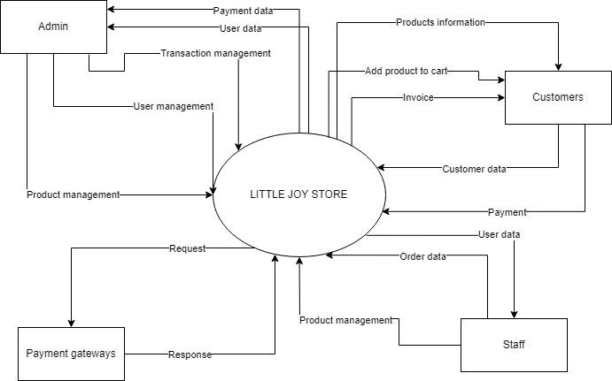

## 

## **2. System Functions**

#### **a. Screen Flow**

1. Member

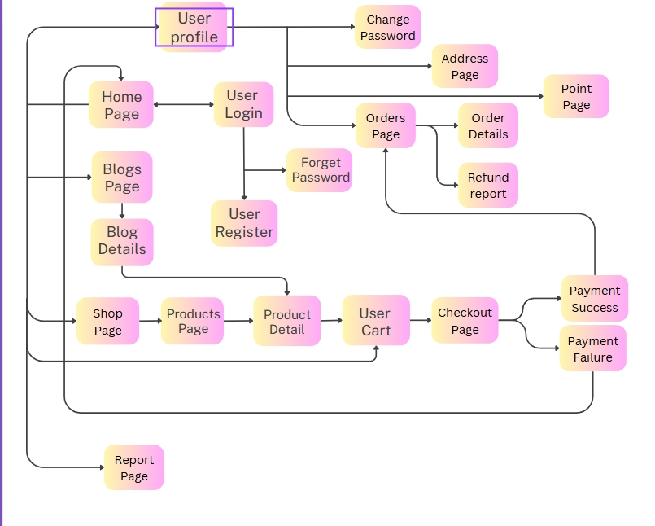

1. Guest

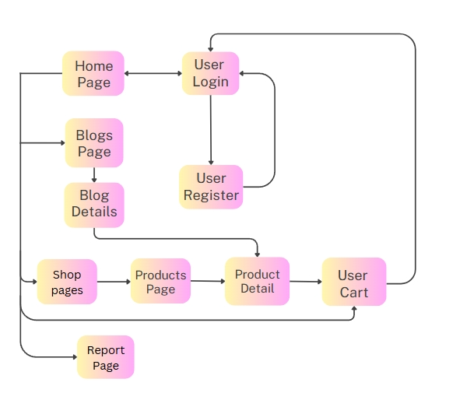

1. Admin

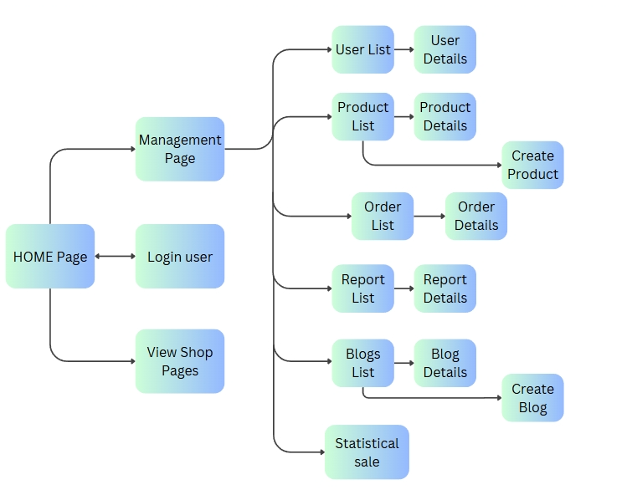

1. Staff

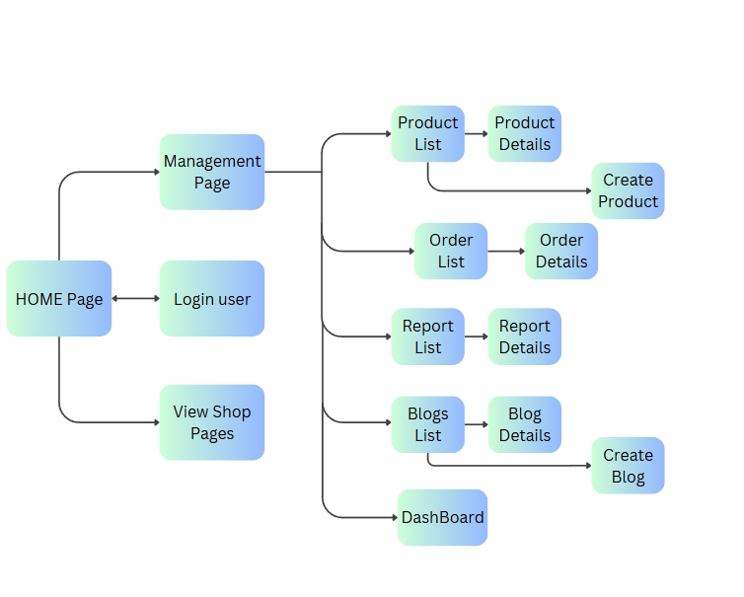

#### **b. Screen Details**

| **#** | **Feature** | **Screen** | **Description** |
| --- | --- | --- | --- |
| 1 | View | Home Page | The home page is the primary landing page for users, offering a comprehensive overview of the platform's offerings. |
| 2 | Edit profile | User Profile | A user space that can view and manage their information |
| 3 | Login/Register | User Login | A login page to check Authentication |
| 4 | Login/Register | User Register | Register a new account to enter a web |
| 5 | Login/Register | Forget Password | Login page when you forget password |
| 6 | Login/Register | Change Password | It is a crucial feature that allows users to update their account security credentials. |
| 7 | View Blog | Blogs Page | A collection of blog that about the health and milk for mother and baby |
| 8 | View Blog | Blog Details | A detail of the Blog |
| 9 | View Product | Products Page | Showcasing the items available for purchase and preOrder |
| 10 | View Product | Product Search | A page that enabling users to find specific items quickly and efficiently |
| 11 | View Product | Product Details | Providing in-depth information about a specific product to help customers make informed purchasing decisions |
| 12 | Buying Products | User Carts | It allows users to review and manage the products they intend to purchase before proceeding to checkout |
| 13 | Buying Products | Payment Pages | A page where users finalise their purchases by providing payment information. |
| 14 | Buying Products | Payment Success | A Page that announce that purchase is complete |
| 15 | Buying Products | Payment Failure | A Page that announce that purchase is failure |
| 16 | Buying Products | Orders Page | It provides users with a comprehensive overview of their purchase history and order status. |
| 17 | Buying Products | Order Details | An order details page provides users with comprehensive information about a specific order they have buy |
| 18 | Buying Products | Refund report | It is a page where users can send a request to refund their goods with obvious reasons and an image. |
| 19 | Manage Users | User List | A list of users who are registered into the system. |
| 20 | Manage Users | User Details | User details page refer to the individual information and attributes associated with a user account within a system |
| 21 | Manage Products | Product List | A product list is a compilation of items available for purchase in Little Joy Store and a status Is the product out of stock? |
| 22 | Manage Products | Product Details | Product details provide comprehensive information about a specific item available for purchase. |
| 23 | Manage Products | Create Product | It is a place that admin and staff can create and give information about the products for selling. |
| 24 | Manage Orders | Order List | The Orders Details screen provides a comprehensive view and management interface for all customer orders received on the platform. |
| 25 | Manage Orders | Order Details | The Orders Details screen provides a comprehensive view and management options for a specific customer order. |
| 26 | Manage Reports | Report List | The Report List screen provides an overview and management view for all reports sent from customers. |
| 27 | Manage Reports | Report Details | The report provides the function of viewing detailed description errors from sender, sender, and image. |
| 28 | Manage Blogs | Blogs List | The Blog List screen provides an overview and management interface for all blog posts created on the platform. |
| 29 | Manage Blogs | Blog Details | The Blog Detail screen provides a comprehensive view and management options for a specific blog post. |
| 30 | Manage Blogs | Create Blog | The Create Blog screen allows staff, admin to create and publish new blog posts on the platform. |
| 31 | Statistical | DashBoard | The dashboard provides an overview of key metrics and statistics related to the product sales. |

#### **c. User Authorization**

| **Screen** | **Admin** | **Staff** | **Member** | **Guest** |
| --- | --- | --- | --- | --- |
| Home Page | x | x | x | x |
| 1.Shop | x | x | x | x |
| 2.Blog | x | x | x | x |
| 3.About | x | x | x | x |
| 4.Report |  |  | x |  |
| User Profile | x | x | x |  |
| 1.View Profile | x | x | x |  |
| 2.Change Password | x | x | x |  |
| 3.View History Order |  |  | x |  |
| 4.Point Exchange |  |  | x |  |
| 5.Address | x | x | x |  |
| User Login | x | x | x |  |
| 1.Login with Email | x | x | x |  |
| 2.Login with Shop Account | x | x | x |  |
| 3.Forgot Password | x | x | x |  |
| User Register |  |  | x | x |
| Blogs Page | x | x | x | x |
| Blog Details | x | x | x | x |
| Products Page | x | x | x | x |
| 1.Product search by keyword | x | x | x | x |
| 2.Product search by filter | x | x | x | x |
| Product Details | x | x | x | x |
| 1.AddToCart |  |  | x | x |
| User Cart |  |  | x | x |
| 1.Buy |  |  | x | x |
| 2.Delete Products from cart |  |  | x | x |
| Payment Pages |  |  | x |  |
| 1.Payment Success |  |  | x |  |
| 2. Payment Failure |  |  | x |  |
| Orders Page |  |  | x |  |
| 1.Report Refund |  |  | x |  |
| Order Details |  |  | x |  |
| Manage Users | x |  |  |  |
| 1. Query Managed users | x | x |  |  |
| 2. Add New users | x |  |  |  |
| 3. Update users data | x | x |  |  |
| Manage Products | x | x |  |  |
| 1. Query Managed products | x | x |  |  |
| 2. Add New product | x | x |  |  |
| 3. Update product data | x | x |  |  |
| 4. Delete product | x | x |  |  |
| Manage Orders | x | x |  |  |
| 1. Query Managed orders | x | x |  |  |
| 2. Update order data | x | x |  |  |
| Manage Reports | x | x |  |  |
| 1. Query Managed reports | x | x |  |  |
| Manage Blogs | x | x |  |  |
| 1. Query Managed blogs | x | x |  |  |
| 2. Add New bogs | x | x |  |  |
| 3. Update blogs data | x | x |  |  |
| 4. Delete blog | x | x |  |  |
| DashBoard | x | x |  |  |

## **Staff:** The staff account is responsible for confirming orders, managing goods and users, handling reports, tracking orders, and managing articles.

**Admin:** Is an individual responsible for managing, maintaining, and overseeing the operations of the system.

## **Member:** Is the user have an account, can login, and can buy products, give feedback, reports to staff

## **Guest:** They are a group of users who have not logged in to an account. They can view information, view reviews, search for dairy products, and view articles about health care for pregnant mothers and babies.

#### ***d. Non-Screen Functions***

| **#** | **Feature** | **System Function** | **Description** |
| --- | --- | --- | --- |
| 1 | User-Friendly Interface | 1. Navigation Menu | 1. The system should have an easy-to-use navigation menu that provides clear links to important sections such as the home page, user profile, product categories, shopping cart and checkout pages. |
| 2. Filter product, search product | 2. Helps users quickly find the type of product they want by using keywords to search or filter according to their needs. |
| 2 | Attractive | Point system | Users will accumulate points for each purchase, with points scaling based on the amount spent. These points will be used to exchange for the product they want. |

## **3. Entity Relationship Diagram**

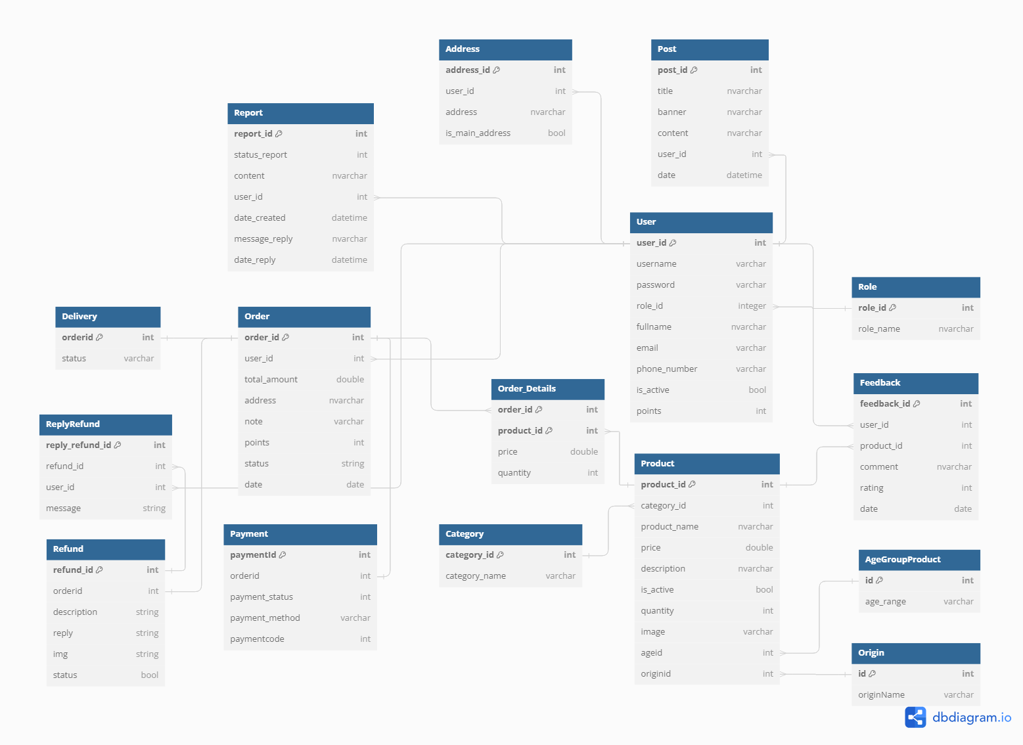

**Entities Description**

| **#** | **Entity** | **Description** |
| --- | --- | --- |
| 1 | User | Represents a person who interacts with the system, either as a guest, member, staff, or admin. |
| 2 | Role | Defines the permissions and access level of a user within the system. |
| 3 | Post | Staff will provide articles related to health care for pregnant mothers and newborns. |
| 4 | Address | Member's delivery address. |
| 5 | Report | Represents reports generated for various purposes, such as order issues, feedback, or system errors. |
| 6 | Product | Represents a milk product available for purchase on the platform. |
| 7 | Order_Details | Represents the details of a specific order, including products and quantities. |
| 8 | AgeGroupProduct | Represents the recommended age group for a particular product. |
| 9 | Origin | Represents the origin or source of a product. |
| 10 | Feedback | Represents user feedback or reviews for products. |
| 11 | Category | Classified by different types of milk. For example: powdered milk, nut milk,... |
| 12 | Order | Represents a customer's order containing one or more products. |
| 13 | Payment | Represents payment details for an order. |
| 14 | Delivery | Save shipping status information for an order. |
| 15 | Refund | This function is used to cancel orders when users report about the product. |
| 16 | ReplyRefund | Respond to users about orders they cancel. |

**. Functional Requirements.**

**1. <<Buy Product>>**

1. **<<ManageCart>>**

**Function trigger:**

_ Users can access the cart by clicking on the "Cart" icon located in the header.

_ Users can click ADD TO CART a product to access “Cart”

**Function description:**

**Actors/Roles**: Staff, Admin, Guest, Member

**Purpose**: Users can add, view, delete, update products that users interested in or users want to buy them.

**Interface**: The cart interface will consist of a list of products added by the user, with options to modify quantities or remove items

**Data Processing:**

**Screen layout**:

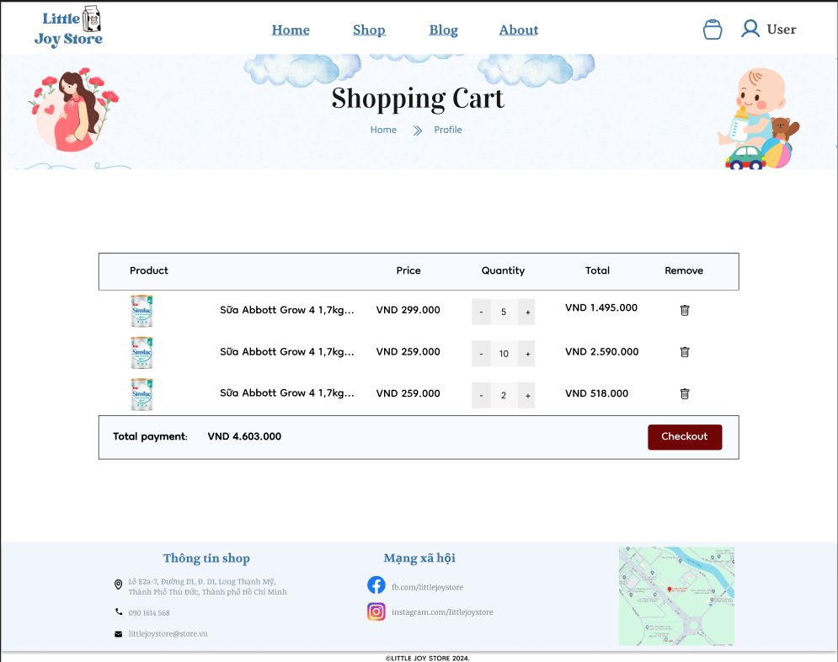

**Function details:**

**Data**:   
 + Information about the products in user carts (name, quantity, price, image, unit price, quantity).  
 + Total price: Calculated by product quantity * unit price  
  
 **Validation**:   
 + Quantity must be a number integer positive, cannot larger the stock of that product.  
 + Items in carts can not disappear when the user goes out the carts page.  
  
 **Business Logics**: Ensuring there is only one cart per customer Creating a cart if none exists or returning an existing one.

**Functionalities:**

+ **Normal Cases**:   
 a. Adding Items: User selects products and clicks  
 the "ADD TO CART"button to add to the user cart.  
 b. Viewing Cart:List of items in user carts with   
 quantities, prices, and totals.  
 c. Updating Quantities: User adjusts the quantity   
 of an item by clicking the button increase or decrease.  
 d. Removing Items: There is a button remove that   
 can dismiss the products out of carts.

**b<<Purchase Product>>**

**Function trigger:**

+ In the users cart, when users want to purchase products, click the Buy button to go to the next step for buying products.

**Function description:**   
 + **Actors/Roles**: Member  
 + **Purpose**: Allow users to purchase products by selecting payment.  
 + **Interface**: The purchase interface includes a list of products that customers choose to buy and the total amount, choose the address and payment through VNpay.  
 + **Data Processing**: The system will validate the payment information, process the payment information, update inventory, and store order details in the database.

**Screen layout**:

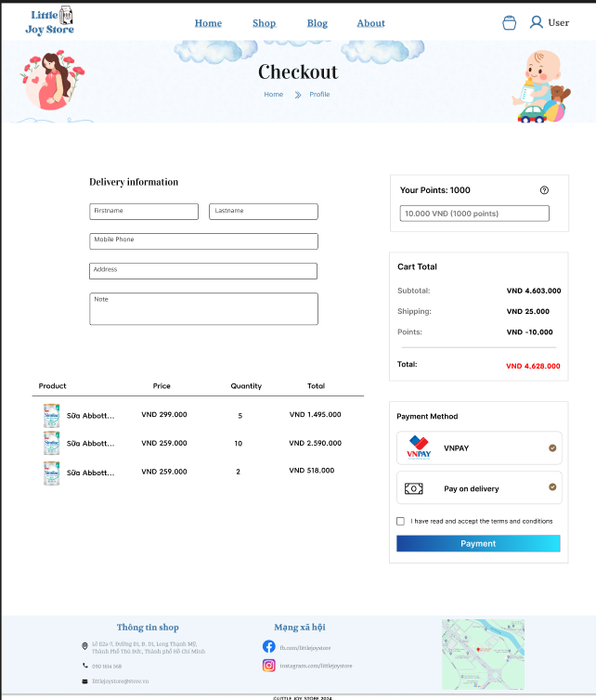

**Function details:**

**Data:**   
 + Information about the products being purchased (name, quantity, price).   
 + Points that users use to change to discount the orders.  
 + User's shipping address  
 + User's payment details

**Validation:**   
 + Ensure that the products are in stock.  
 + Validate the shipping address fields.  
 + Validate the payment details  
 + Ensure that the order information is correct.  
   
 **Business Logics**:   
 + The system checks the stock levels of each product to ensure availability. If any item is out of stock, it notifies the user and removes the item from the cart.  
 +The system updates the inventory levels to reflect the purchased quantities.  
 + If the shipping address is found to be invalid, the system displays an error message asking the user to correct the address before proceeding.

**Functionalities:** + **Normal Cases**:   
 1. Review Cart: User reviews the cart and clicks "Buy"  
 2. Enter Shipping Information:  
 + User enters or selects a shipping address.  
 + System validates the address.  
 + User clicks "Next" to proceed.  
 3. Select Payment Method:  
 + User selects a payment method and   
 enters the payment details.  
 + System validates the payment   
 information.  
 + User clicks "Next" to proceed.  
 4 Review and Confirm Order:  
 + User reviews the order summary.  
 + User clicks "Confirm."  
 + System processes the payment.  
 + System updates inventory.  
 + System stores order details in the database.  
 + System sends a confirmation email to the user.

+ **Abnormal Cases**:   
 1. If an item is out of stock, the user can not complete   
 buying products  
 2. If the shipping address is invalid, an error message   
 is displayed. Users must correct the address before   
 proceeding.

3. If the payment information fails, an error message   
 is displayed. Users can try payment again or cancel the   
 payment.

**c.<<Order Tracking>>**

**Function trigger:**

- Navigation Path:

+ The user clicks on "Profile" in the user menu after  
 logging in.

+ The user clicks the "Quản lý đơn hàng" to check the   
 status order.

**Function description:**

- **Actors/Roles**: Member

- **Purpose**: Allows users to track the current status of an order   
 from order placement to successful delivery.

- **Interface**: The interface displays order details and current   
 status.

- **Data Processing**: The system retrieves order information from   
 the database and updates order information from staff.

**Screen layout**:

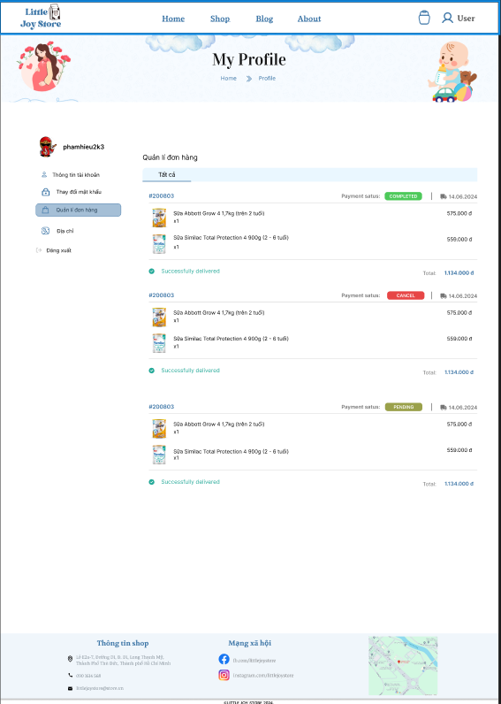

**Function details:**

- **Data**: Order information, product information, order status,  
 order date.

- **Validation**: Check the validity of order information retrieved   
 from the database. Ensure that only relevant members can   
 access their order information.

- **Business Logics**: Order information and status are updated in  
 real time from the shipping unit.

- **Functionalities**:

+ **Normal Cases**: Displays details and current status of   
 the order. Update order status in real time. Users can  
 contact support if there is a problem with their order.

+ **Abnormal Cases**: If order information cannot be   
 retrieved, display an error message and ask the user to   
 try again later. If the order status is not updated, display a   
 message and provide support contact information.

**d<<Refund Order>>**

**Function trigger:**

- Navigation Path:

+ The user clicks on "Profile" in the user menu after  
 logging in.

+ The user clicks the "Quản lí đơn hàng" to check the   
 status order.

+ The user selects the order they want to refund, then  
 clicks "Report".

**Function description:**

- **Actors/Roles**: Member

- **Purpose**: Allow users to request a refund if they are not   
 satisfied with the product or have a problem with the order.

- **Interface**: The interface displays information about the report   
 form.

- **Data Processing**: The system records the return request and  
 sends contact information to the supplier for processing.

**Screen layout**:

**Function details:**

- **Data**: Order information to be returned, reason for return  
 request, user contact information.

- **Validation**: Check the validity of the entered information  
 (cannot be blank, valid email format, valid phone number).

- **Business Logics**: The refund request is recorded and sent to   
 the supplier for processing.

- **Functionalities**:

+ Normal Cases: The user enters the return request   
 information and contact information, then submits the   
 request. The system records the request and forwards it   
 to the supplier for processing.

+ Abnormal Cases: If there is an error sending the refund   
 request, display an error message and ask the user to try  
 again later.

**2. <<User Profile Management>>**

**a<<Manage information users>>**

**Function trigger:** Accessible from the user profile page, via an   
 "Lưu Thay Đổi" to change information of users

**Function description:**   
 + **Actors/Roles**: Staff, Admin, Member  
 + **Purpose**: To allow users to view and update their personal  
 information such as fullname, email address, phone number,  
 image.   
 + **Interface**:A form where users can view and edit their   
 personal information. This form include input fields and button   
 "Lưu Cập Nhập" to change the user information store in   
 database.  
 + **Data Processing**: The system validates the input of users and   
 saves the updated information to the database.

**Screen layout**:

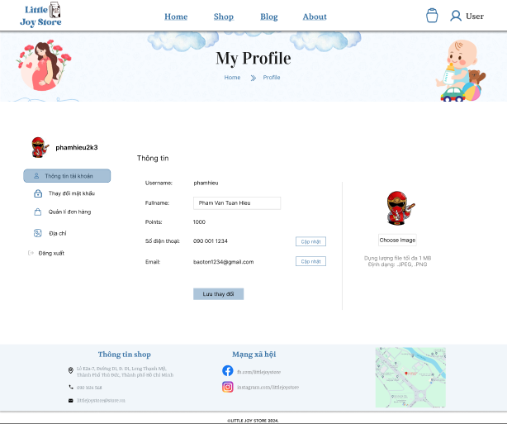

**Function details:**

**Data**: User’s personal information including name, email address, phone number, image.  
  
 **Validation**:   
 + Ensure mandatory fields such as name and email are   
 not left blank.  
 + Validate that the email address is in the  
 correct format.   
 + Validate the phone number format to ensure it contains  
 only 10 numbers  
   
 **Business Logics:**   
 + Ensure that updates do not conflict with existing data.  
 + Display appropriate error messages for validation   
 failures and unsuccessful updates.

**Functionalities:**  
 + **Normal Cases**:   
 + User views their current information in the form.  
 + User updates the fields they want to change and   
 clicks "Save Changes."  
 + The system validates the input and saves the   
 updated information to the database.  
 + The user is redirected to the profile view page   
 with a success message.

+ **Abnormal Cases**:   
 1. Display error messages if required fields are   
 missing or if inputs are invalid   
 2. Display an error message if there is a problem   
 saving the data

**b<<Change password>>**

**Function trigger:** Accessible from the sidebar of user profile page   
 choose the "Thay đổi mật khẩu"

**Function description:**   
 + **Actors/Roles**: Staff, Admin, Member  
 + **Purpose**: To allow users to change their account password   
 for security reasons.   
 + **Interface**:A form with fields for the current password and there   
 is an option forget password next to, field for new password,   
 and confirmation of the new password.   
 + **Data Processing**: System will check the password of users  
 input in database and update the new password to database.

**Screen layout**: (img)

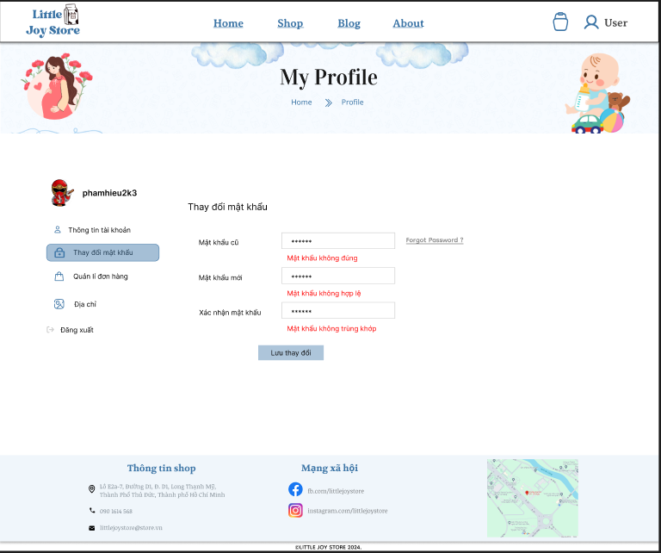

**Function details:**

**Data**: User’s Current password, new password, confirmation of   
 the new password.  
  
 **Validation**:   
 + Verify that the current password matches the user’s   
 existing password in the database.  
 + The new password must be at least 6 characters long,   
 and contain at least one uppercase letter, one lowercase letter,   
 one number, and one special character.  
 + Ensure the new password and confirmation password  
 fields match.   
   
 **Business Logics:**   
 + The new password and confirmation password must   
 match exactly.  
 + Ensure the new password meets security criteria  
 + When successful password change, notify the user with  
 a confirmation message

**Functionalities:**  
 + **Normal Cases**:   
 + User enters the current password, new  
 password, and confirmation of the new password.  
 + The system validates the inputs.  
 + If validation passes, the new password is saved  
 in the database.  
 + The user is redirected to a confirmation page  
 with a success message.

+ **Abnormal Cases**:   
 1. Display error messages if the current password  
 is incorrect and the new and confirmation   
 passwords do not match.   
 2. If the users forget password, user can update  
 the password by email address and OTP:  
 a. User enter a email address and system  
 will verify the email exists in the database.  
 b. There will be an OTP code sent to that   
 email, if the input OTP that system receives is   
 correct so that the user can change password. If   
 not the action will cancel.

**c<<Manage User Orders>>**

**Function trigger:** Accessible from the sidebar of user profile page   
 choose the "Quản lý đơn hàng"

**Function description:**   
 + **Actors/Roles**: Member  
 + **Purpose**: To allow users to view and manage their past and  
 current orders, including tracking order status, viewing order  
 details, and start off refund order.   
 + **Interface**:A page displaying a list of the user’s orders with   
 options to view details, track status.   
 + **Data Processing**: The system return a list of order that users   
 have a database with status of that order.

**Screen layout**:

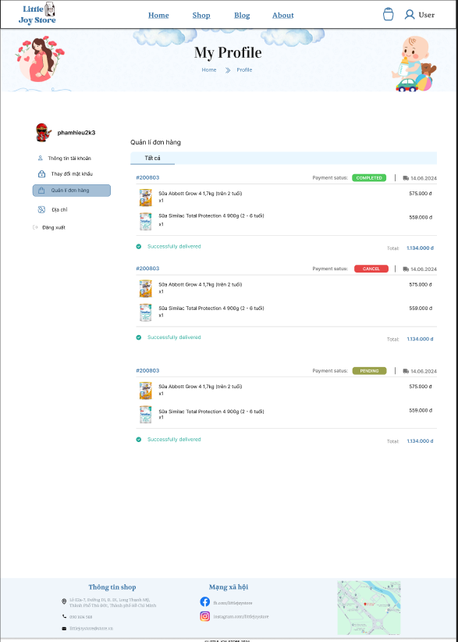

**Function details:**

**Data**: List of orders with details such as order ID, date, status,   
 total amount, point use, point earn and option to refund the products  
  
 **Validation**:   
 + Ensure the user is logged in to access their order history.  
 + Verify that the orders being accessed belong to the user   
 that log in to the system.  
   
 **Business Logics:**   
 + Display a list of all orders placed by the user, sorted by   
 date with the most recent orders first.  
 + Provide detailed information for each order detail,   
 including items purchased, quantities, prices, and shipping  
 status.  
 + Enable users to start off return orders when there is   
 an error of that order.

**Functionalities:**  
 + **Normal Cases**:   
 + User views a list of their orders with basic   
 information (order ID, date, status, total amount).  
 + User clicks "Order information" to see detailed  
 information about an order.  
 + User clicks "Refund Order" to start off return  
 process for a delivered order.

+ **Abnormal Cases**:   
 1. If a user tries to cancel or return an order that  
 the reason for refund is not accepted for refund:  
 "This order cannot be cancelled/returned at this stage."  
 2. If there is a problem retrieving order data or   
 processing actions, display a message: "An error   
 occurred. Please try again later."

**d<<Manage default address>>**

**Function trigger:** Accessible from the sidebar of user profile page   
 choose the "Địa chỉ"

**Function description:**   
 + **Actors/Roles**: Member  
 + **Purpose**: To allow users to view, add, update, and set their   
 default shipping address.   
 + **Interface**:A form for adding or editing addresses, and a list of  
 saved addresses with options to set the default address.   
 + **Data Processing**: The system will return a list of addresses   
 with the main address that the user created .

**Screen layout**:

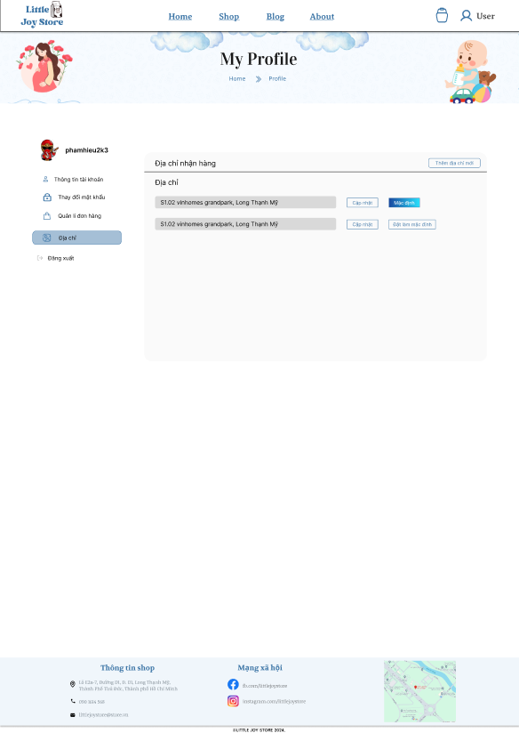

**Function details:**

**Data**:User’s address information including main address belong  
 to the user.  
  
 **Validation**:   
 + Validate the format of the address to ensure they  
 meet correct standards..  
 + Ensure that each address entered is unique to prevent  
 duplicates.  
  
 **Business Logics:**   
 + Allow users to set one address as the default.  
 + Enable users to edit existing addresses or add new ones.

**Functionalities:**  
 + **Normal Cases**:   
 + User views a list of their saved addresses.  
 + User clicks "Thêm Địa Chỉ Mới" to open a form   
 for adding a new address.  
 + User fills out the address form and saves the   
 new address.  
 + User clicks "Edit" to update an existing address   
 and saves the changes.  
 + User clicks "Đặt Làm Mặc Định" to designate an   
 address as the default.  
 + The system updates the address list to reflect   
 the new default address and provides a success message.

+ **Abnormal Cases**:   
 1. Display error messages if required fields are   
missing or if the address format is invalid.   
 2. If the user tries to delete the current default address without setting a new default, display an error message: "Please set another address as default before deleting this one."  
 3. Display an error message if there is a problem saving the new or updated address.

**e<<Manage Point>>**

**Function trigger:** Accessible from the user profile page   
 choose the "Thông tin tài khoản"

**Function description:**   
 + **Actors/Roles**: Member  
 + **Purpose**: To allow users to view, earn, and redeem points to   
 money discount.   
 + **Interface**:A page displaying point earn by customer and the list of how points are exchanged for money.  
 + **Data Processing**: The system returns a point that users earn.

**Screen layout**: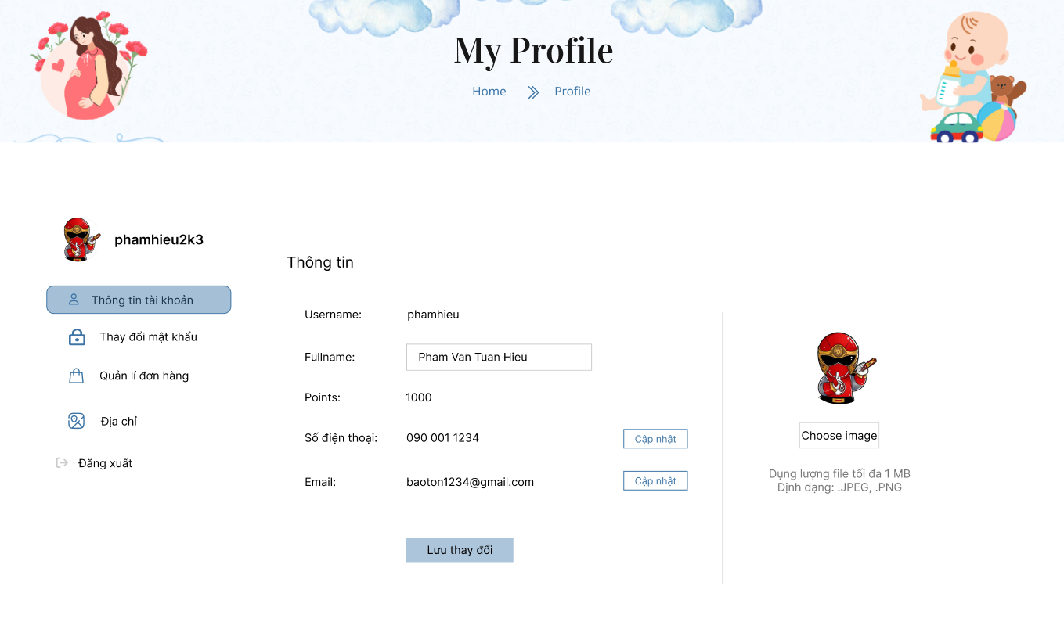

**Function details:**

**Data**: Users point when purchasing orders.  
  
 **Validation**: Ensure the user has enough points for any redemption   
 actions.  
   
 **Business Logics:** Ensure the user has enough points for any   
 redemption actions.

**Functionalities:**   
 + **Normal Cases**:   
 + User views their current points balance and the   
 list of how points are exchanged for money.  
 + When the user is in the process of confirming the order, the points can be used if there are enough to choose the money discount that the user wants.

+ **Abnormal Cases**:   
 + Display an error message if the user tries to redeem more points than they have: "Insufficient points for this redemption."  
 + Display an error message if there is a problem updating the points balance when purchased order: “Save point failure”

**f<<Log Out>>**

**Function trigger:** Accessible from the sidebar of user profile page   
 choose the "Đăng Xuất"

**Function description:**   
 + **Actors/Roles**: Member  
 + **Purpose**: To allow users to securely end their session and log   
 out of their account.   
 + **Interface**: A link that logs the user out and redirects users to   
 the home page.  
 + **Data Processing**: The system will check the account user  
 then end the session and redirect to the home page.

**Screen layout**:

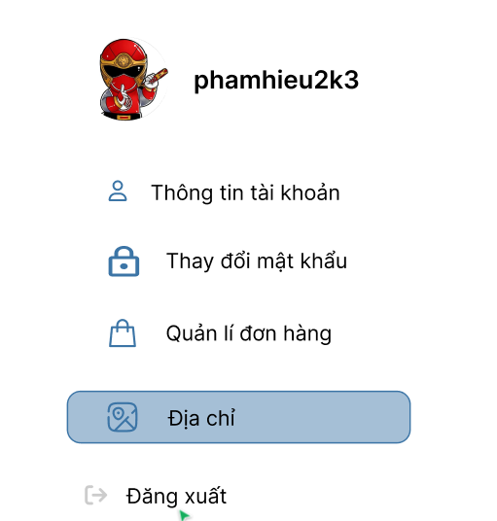

**Function details:**

**Data**: The request for logout  
  
 **Validation**: Ensure the user is currently logged in before allowing the  
 log out process to proceed.   
   
 **Business Logics:**   
 + End the user's session by invalidating the session token.  
 + Redirect the user to a home page after successfully logout.

**Functionalities:**   
 + **Normal Cases**:   
 + User clicks the "Đăng Xuất" link.  
 + The system invalidates the user's session token  
 and clears session cookies.  
 + The user is redirected to the home or login page   
 with a success message indicating they have logged out.

**3. <<Product Reviews and Ratings>>**

**Function trigger:** Accessible from the product page

**Function description:**   
 + **Actors/Roles**: Member, Guest(Can only view)  
 + **Purpose**: To allow users to share their experiences and   
 opinions about a product and provide feedback to other   
 potential buyers.   
 + **Interface**:A form for submitting reviews and choosing star for   
 rating, and a list displaying existing reviews and ratings.  
 + **Data Processing**: The system returns list existing reviews and   
 ratings and add a new reviewing to the database

**Screen layout**:

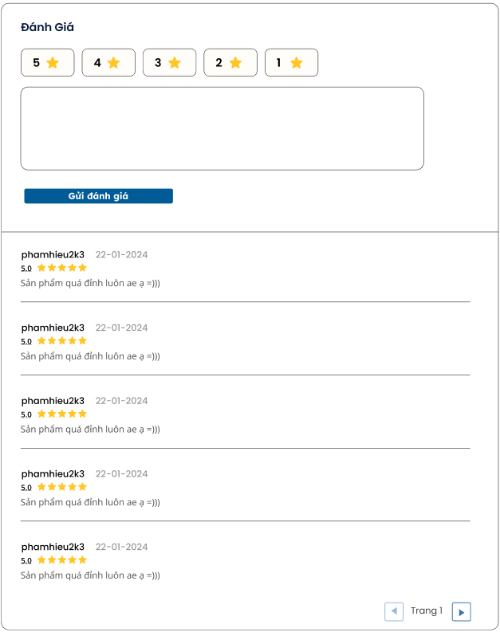

**Function details:**

**Data**: User's review rating (1 to 5 stars), review text, review   
 date..  
  
 **Validation**:   
 +Validate that the rating is within the range of 1 to 5 stars.  
 + Limit the review text length to a reasonable number of  
 characters   
 **Business Logics:**  
 + Implement a star rating system where users can select   
 1 to 5 stars to rate a product.  
 + Display submitted reviews along with reviewer name,   
 date, rating, and text.

**Functionalities:**   
 + **Normal Cases**:   
 + User fills out the review form with rating and text.  
 + User submits the review, and it is displayed in   
 the product's review section.  
 + Other users can read the review, see the rating,   
 and find it helpful.

**4. <<User Consultation>>**

**Function trigger:**

- Navigation Path: Clicks on “chatbox” from home page

**Function description:**

- **Actors/Roles**: Member

- **Purpose**: Get advice from employees about products or their   
 own needs.

- **Interface**: live chat.

- **Data Processing**: Document consultation requests or blog  
 posts related to customer product needs.

**Screen layout**:

**Function details:**

- Process and check the validity of data, forward consulting requests to blog articles related to user needs.

**5. <<Product Search>>**

**a<<Search by search bar>>**

**Function trigger:** The search bar is accessible from the shoppage,   
 located at the header of the web.

**Function description:**   
 + **Actors/Roles**: Staff, Admin, Guest, Member  
 + **Purpose**: To allow users to search for content of products. + **Interface**:The search bar will consist of a text input field with a   
 search button adjacent to it.  
 + **Data Processing**: The search query entered by the user will   
 be sent to the server, which will process the query and return a  
 list of relevant results based on the content or product   
 database.

**Screen layout**: (img)

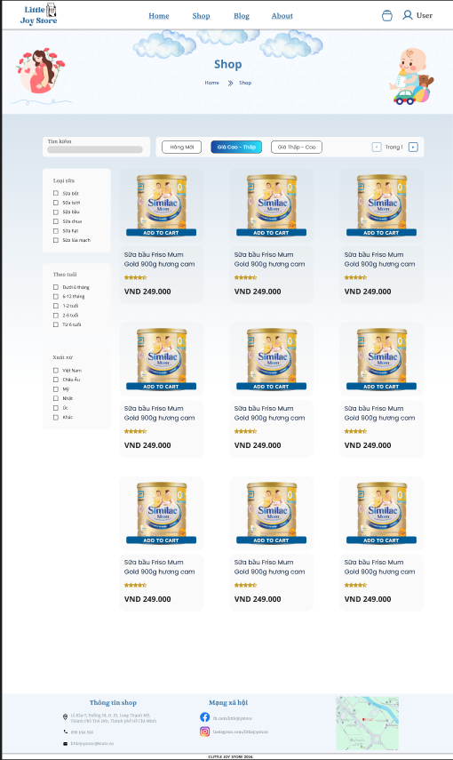

**Function details:**

**Data**:   
 + User’s search information

**Validation**:   
 + If the search is empty and the user presses "Enter" or clicks the "Search" button, The lists will return order descending by the create day of products  
   
 **Business Logics:**   
 + When pressing "Enter" or clicking the "Search" button, the search query is sent to the backend server and the server processes the query against the database and returns relevant results.

**Functionalities:**  
 + **Normal Cases**: User enters a search query, suggestions appear, and results are displayed upon search execution.

+ **Abnormal Cases**:   
 1. Display a message: "No results found for your search." when no results in the database.  
 2. If the query exceeds the character limit of 100 characters, display a message: "Search query is too long. Please shorten your search term."

**b<<Search by filter>>**

**Function trigger:** The filter search function is accessed via a  
 sidebar of the shoppage

**Function description:**   
 + **Actors/Roles**: Staff, Admin, Guest, Member  
 + **Purpose**: To allow users to narrow down search results based  
 on specific criteria such as ages, price, origin, milk types.   
   
 + **Interface**: The filter section will be displayed as a sidebar  
 with multiple filter options that users can select or deselect.   
 + **Data Processing**: The selected filter options will be sent to   
 the server, which will process these criteria and return a list of search  
 results.

**Screen layout**:



**Function details:**

**Data**: User’s selected filter options

**Validation**: If the selected filters return result in no possible  
 matches, display a message: "No results found. Please adjust   
 your filters."  
   
  **Business Logics:**   
 + The filter options should be dynamically generated   
 based on available data.  
 + Each filter option should have a clear label and allow   
 multiple selections where applicable

**Functionalities:**  
 + **Normal Cases**: User selects one or more filters and   
 applies them to the search results. The results update to reflect  
 the selected filters.

+ **Abnormal Cases**: No Results Found: Display a message: "No results found for the selected filters. Please adjust your filters."

**6. <<Product Management>>**

**Function trigger:**

- Navigation Path: Administrator and staff access the admin or  
 staff console and select "Product Management".

**Function description:**

- **Actors/Roles**: Admin/staff

- **Purpose**: Allows administrators or staff to add, edit, delete and  
 manage detailed information of dairy products for pregnant   
 mothers and babies.

- **Interface**: The interface provides forms for entering product  
 information, editing existing information, and managing product  
 catalogues.

- **Data Processing**: The system records new product   
 information or updates existing product information in the   
 database.

**Screen layout**:

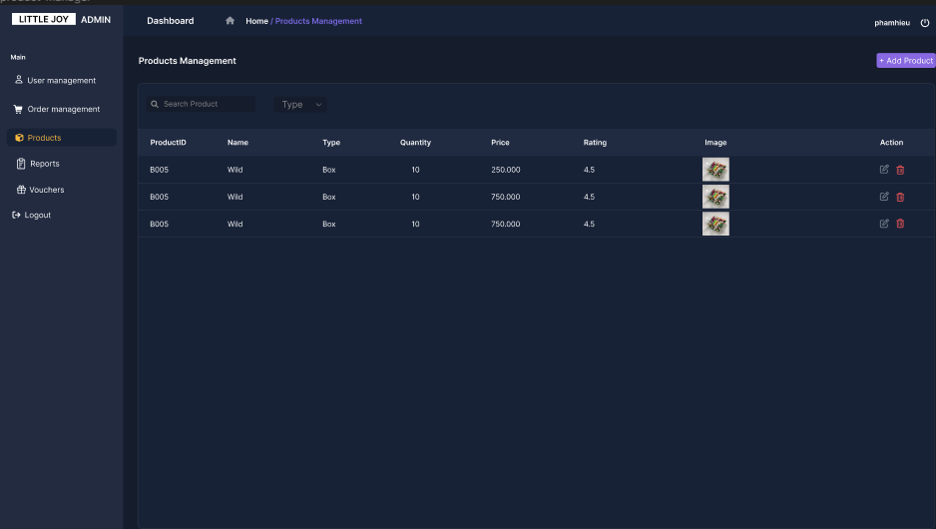

**Function details:**

**Data**: Product information includes name, description, price,  
 inventory, images, category, suitable age, and origin.

**Validation**:Check the validity of the entered information (do not   
 leave required fields blank, price must be a positive number,   
 inventory quantity must be a positive integer).  
   
  **Business Logics:**   
 + When adding a new product, check if the product   
 already exists (based on name and category).

+ When deleting a product, check to see if the product is  
 in the current order before deleting (update status).

+ When editing products, update product information in  
 the database.

**Functionalities:**  
 - Process and check the validity of data, check the   
 existence of products before adding or deleting, and   
 update product information in the database.

**7. <<Order Management>>**

**Function trigger:**

- Navigation Path: Administrator and staff access the admin or  
 staff console and select "Order Management".

**Function description:**

- **Actors/Roles**: Admin/staff

- **Purpose**: Allows administrators to view, update status, and   
 manage order details.

- **Interface**: The interface provides order lists, order details, and   
 forms to edit order status.

- **Data Processing**: The system records and updates order   
 status in the database, including adding, updating and deleting   
 orders.

**Screen layout**:

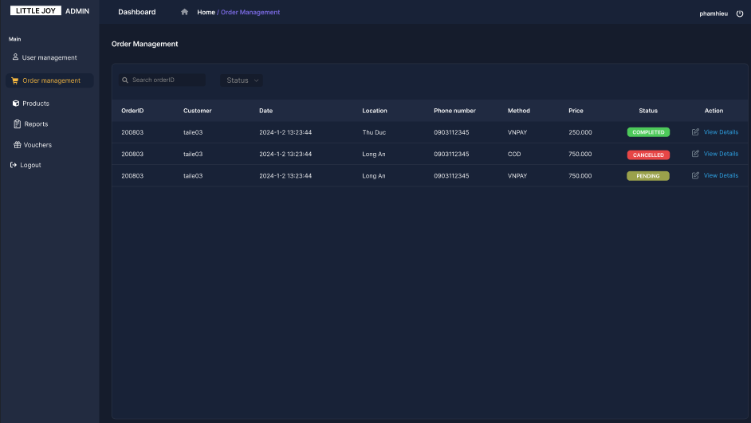

**Function details:**

**Data**: Order information includes order ID, customer name,   
 address, product list, total amount, order status, and order date.

**Validation**: Check the validity of the entered information (order   
 status is valid, do not leave required fields blank).  
   
  **Business Logics:**   
 + When adding a new order, check product and customer   
 information.

+ When updating order status, the system must check the   
 current status and confirm the change is valid.

**Functionalities:**  
 + **Normal Cases**: Staff edits order status and updates to   
 database. Admin removes orders from the list if there is a   
 problem with the order.

+ **Abnormal Cases**: If there is an error while saving or updating an order, an error message is displayed.

**8. <<User Management>>**

**Function trigger:**

- Navigation Path: Administrator access the admin console and  
 select "User Management".

**Function description:**

- **Actors/Roles**: Admin

- **Purpose**: Allows administrators to add, edit, delete and  
 manage detailed information on the customer list.

- **Interface**: The interface provides user lists, user details, and   
 forms to edit user information.

- **Data Processing**: The system records and updates user   
 information in the database, including adding, editing, and   
 deleting user account information (change active status of   
 account user).

**Screen layout**:

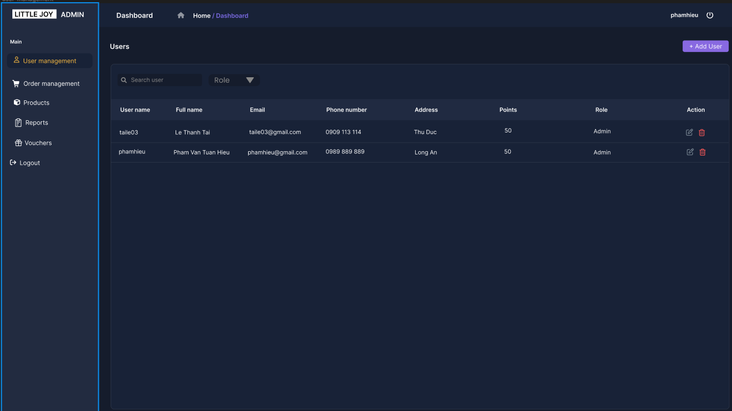

**Function details:**

**Data**: User information includes name, email, phone number,   
 address, role, and status (Active Status).

**Validation**: Check the validity of the entered information (valid   
 email, correct phone number format, do not leave required fields   
 blank).  
   
  **Business Logics:**   
 + When editing user information, update the information   
 in the database.

+ When deleting a user, check if the user is involved in   
 current transactions before deleting (change status of   
 account).

**Functionalities:**  
 + **Normal Cases**: The administrator enters new user   
 information and saves it to the system. The administrator   
 edits existing user information and updates it to the   
 database. Administrators remove users from the list if no   
 longer needed.

+ **Abnormal Cases**: If there is an error while saving or   
 updating a user, the system will retain the original data   
 before the change due to some problem.

**9. <<Blog Management>>**

**Function trigger:**

- Navigation Path: Administrator and staff access the admin or  
 staff console and select "Blog Management".

**Function description:**

- **Actors/Roles**: Admin/staff

- **Purpose**: Allows admin and staff to create blogs, edit, delete   
 and manage blog posts.

- **Interface**: The interface provides article lists, article details,   
 and forms to create and edit articles.

- **Data Processing**: The system records new article information   
 or updates existing article information in the database.

**Screen layout**:

**Function details:**

- **Normal Cases**:   
 + Administrator or staff enter new article information and   
 save it into the system.

+ Administrator or staff edit existing article information   
 and update it to the database.

+ Administrator or staff remove articles from the list if no   
 longer needed.

- **Abnormal Cases**:   
 + If there was an error while saving or updating the post,   
 display an error message.

**10. <<Manage feedback and rating>>**

**Function trigger:** Accessible from the sidebar of manager page   
 and choose the "Feedback" in th sidebar

**Function description:**   
 + **Actors/Roles**: Admin and staff  
 + **Purpose**: To collect, analyse, and manage feedback and   
 ratings provided by users to improve products, services, and   
 overall customer experience.   
 + **Interface**:   
 + **Data Processing**: System return a list of feedback with comment, rating , date created of a member that create feedback

**Screen layout**:

**Function details:**

**Data:** Feedback and ratings data, including product details, user  
 information, date, and feedback text.  
  
 **Validation**:   
 + Collect feedback and ratings provided by users for  
 products, services, or overall experience.  
 + Validate the day created feedback can not higher a   
 present day  
  
 **Business Logics:**   
 + Receive error reports submitted by users, including   
 detailed information  
 + Allow administrators to respond to user feedback.

**Functionalities:**  
 + **Normal Cases**:   
 + Users provide feedback and ratings for products,   
 services, or overall experience.  
 + Administrators review feedback received,  
 analyse data, and respond to users as appropriate.

+ **Abnormal Cases**:   
 + Display error messages if required fields are missing  
 + Staff and Admin can communicate with the users about   
 their feedback

**11. <<Report management>>**

**Function trigger:** Accessible from the sidebar of manager page   
 and choose the "Report" in th sidebar

**Function description:**   
 + **Actors/Roles**: Admin and staff  
 + **Purpose**: To manage and handle reports that user send give   
 reports about the system and error discovery.   
 + **Interface**:   
 + **Data Processing**: System return a list of report with content,   
 date created of a member that create reports

**Screen layout**: (img)

**Function details:**

**Data**: List of report which was maked by members which taken   
 from the database  
  
 **Validation**:   
 + Validate the created day can not higher than the   
 present day.  
  
 **Business Logics:**   
 + Receive error reports submitted by users, including   
 detailed information  
 + Track the status of reported errors from submission to   
 resolution.

**Functionalities:**  
 + **Normal Cases**:   
 + User encounters an error within the system or  
 unsatisfied about the system, the member submits an error  
 report, providing details about the error and description.  
 + Staff reviews the reported errors, find   
 resolutions, and tracks their progress.  
 + When staff resolve a problem can send a reply in  
 that report to that member.

+ **Abnormal Cases**:   
 + Return a reply sorry if the error can not be solved,   
 or poor review of the system.  
 + Ensure that admin and staff can track the status of   
 reported errors and provide updates to members.